**VIETNAM NATIONAL UNIVERSITY, HANOI INTERNATIONAL SCHOOL**

| REPORT OF FINAL EXAM PROJECT  **Subject: Java Programming**   | **Group: 11**  **Lecturer: Nguyen Dang Khoa**  **Level: Undergraduate**  **Time allowed: 02 weeks.** | **Members:**   1. Nguyễn Thu Phương 2. Nhữ Quang Minh 3. Nguyễn Thế Hùng 4. Thân Quang Huy 5. Nguyễn Thị Ngọc Diệp | | --- | --- | |
| --- | --- | --- |

**TABLE OF CONTENTS**

**I) INTRODUCTION………………………………………………3**

**II) ANALYSIS & SURVEY………………………………………8**

**III) DATABASE DESIGN ………………………………………..14**

**IV) USER INTERFACE…………………………………………..14**

**V) CODING & RELEASE………………………………………..15**

**VI) CONCLUSION………………………………………………..17**

**VII) REFERENCES……………………………………………….19**

**VIII) CONTRIBUTION……………………………………………20**

**I) INTRODUCTION**

In an increasingly globalized world and the continuous development of information technology, the application of software solutions in football management and development is becoming increasingly important. This report focuses on analyzing, designing, and implementing football player management software.

This software not only helps track each player's information, but also provides tools to manage each aspect of a group of football club, manage training schedules. The software will provide detailed information , and analytical data to help management better understand each player's performance.

In addition, the software also helps manage players' training schedules, helping to ensure that they are receiving proper training and are not overloaded. The software can also help find new talent by analyzing data from youth tournaments and helping managers evaluate the potential of young players.

By taking advantage of technology, we can improve management quality, optimize work processes, and promote the development of football. However, implementing such a system also requires a deep understanding of information technology and project management, as well as financial and human resource commitment.

Please note that this is an overview only and specific risks may vary depending on the company's specific circumstances and the legal regulations in the countries in which the company operates. We developed this project with Eclipse and I think this is important software for every club in the world to manage and develop.

**II. ANALYSIS & SURVEY**

**SUMMARY ABOUT THE SYSTEMS**

Our Football Management Software is designed to streamline the administration and operation of football clubs. It offers a comprehensive suite of tools to manage players, coaching staff, transfers, facilities, and tournaments. Key features include:

* **Player Management**: Detailed player profiles, statistics, injury tracking, and performance metrics.
* **Coach Management**: Detailed coach profiles, and performance reviews.
* **Transfer Window**: Tools for managing player transfers, including transfer lists, initiation of transfers, and history.
* **Staff Management**: Profiles and roles for administrative and support staff, payroll management.
* **Ground and Gym Management**: Overview of the players’ schedule and training status.
* **Tournament Management**: Information on upcoming tournaments, match schedules, and result tracking.

**DEFINE PROBLEM AND CONSTRAIN**

* **Problems:**
* **User Adoption**: The software must ensure that it is easy to use for all users, even those who are not too good at technical issues.
* **Real-Time Updates**: Keeping all information, particularly player statistics and injury reports, up to date in real-time.
* **Security**: Protect the confidential, sensitive data of the players in the club from unauthorized access and security breaches.
* **Constrain:**
* **Budget Limitations**: Financial constraints that may limit the ability to invest in advanced features or hardware.
* **Time Constraints**: The time required for staff to transition from traditional management methods to the new software.
* **Technical Infrastructure**: Ensuring that the existing IT infrastructure can support the software’s requirements.
* **Compliance**: Adhering to regulations and standards related to data protection, particularly concerning player and staff information.

**DEFINE OBJECTIVES**

The main goal of our Football Management Software is to help the section improve efficiency, improve data management, and support strategic decision-making in football clubs. Specifically:

* **Streamline Operations**: Automate and simplify administrative tasks, reducing the workload on staff and allowing them to focus on core activities.
* **Enhance Player and Staff Management**: Provide detailed insights and tools for managing players, coaches, and staff, improving overall team performance.
* **Optimize Transfers**: Support effective transfer decisions and comprehensive transfer history.
* **Ensure Security and Compliance**: Implement robust security measures to protect sensitive data and comply with relevant regulations and standards.

By solving these problems and limitations while focusing on defined goals, our Football Management Software aims to provide robots and effective solutions to manage every aspect of a standard football club, helping to achieve certain successes.

**III. DATABASE DESIGN**

1. **Determine end-user views, outputs, and transaction-process requirements**

The Database of Football Management System is designed as a system application that includes information such as Player, Coach, Buy and sell the player. It also allows the owner to store, manage, and retrieve data quickly. To conclude, the Database of Football Management System helps the organization manage football club information

1. **Entity relationship modeling and normalization**

The table shown below signifies the entities, attribute relationships, and keys that are involved in the Database of Football Management System

|  | Entities | Attributes |
| --- | --- | --- |
| 1 | DBLogin | * UserID * UserName * UserPassword |
| 2 | Team | * Team_ID * Team_Name |
| 3 | Player | * P_ID * P_Name * P_Pos * P_Age * P_SEX * P_Weight * P_Height * P_Nation * P_Rating * P_Medical_Condition * P_Salary * P_Performance_Bonus * P_LEAVE * P_Description * Team_ID |
| 4 | Coach | * C_ID * C_Name * C_Formation * C_Designation * C_Age * C_Sex * C_Medical_Condition * C_Salary * C_Performance_Bonus * C_Description * Team_ID |
| 5 | Staff | * S_ID * S_Name * S_Type * S_Age * S_Sex * S_Medical_Condition * S_Salary * S_Contract_Year * S_Release_Date * S_InLeave INT NULL, * Team_ID |
| 6 | Tournament | * Tm_ID * Tm_Match_Type * Tm_Stadium * Tm_Match_Area * Tm_Date * Tm_Opponent * Tm_Result * Tm_Match_Fee REFERENCES Team_ID |
| 7 | GroundandGym | * GG_No * GG_Name * GG_Type * GG_Capacity * GG_Description * S_ID |
| 8 | BUYTABLE | * TSP_ID * TSP_NAME * TSP_AGE * TSP_HEIGHT * TSP_NATIONALITY * TSP_POSITION * TSP_MVA * TSP_CAPS * TSP_GOALS * TSP_CURRENT_CLUB * TSP_TRANSFERFEE |
| 9 | SELL_TABLE | * SELL_ID * SELL_MVA * SELL_TRANSFERFEE * SELL_CAPS * SELL_GOAL |

1. **Relationship among entities**

* A team can have many Players (one-to-many).
* A Player belongs to one Team (many-to-one).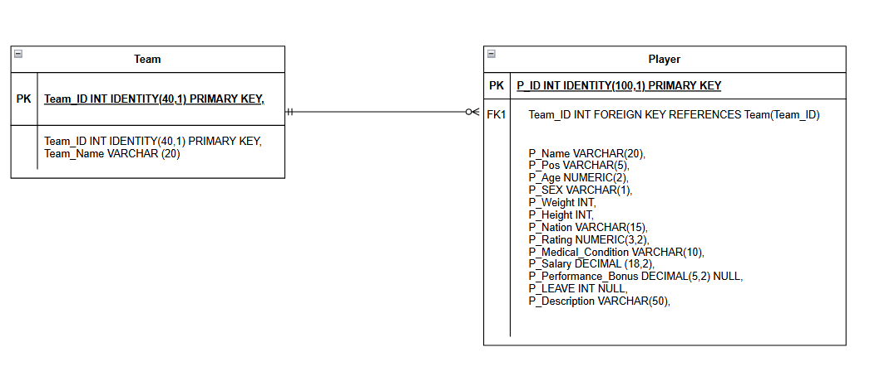
* A Team can have many Staff (one-to-many).
* A staff member can be associated with one Team (many-to-one).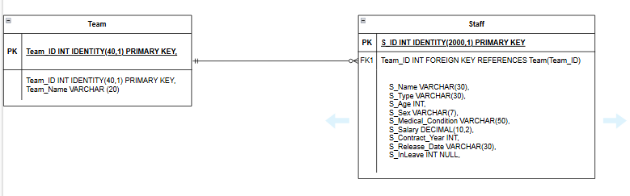
* A Team can participate in many Tournaments (many-to-many).
* A Tournament can have many Teams participating (many-to-many).

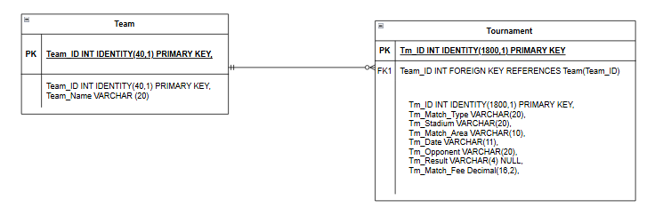

* A Match involves two Teams (many-to-many).
* A team can have one coach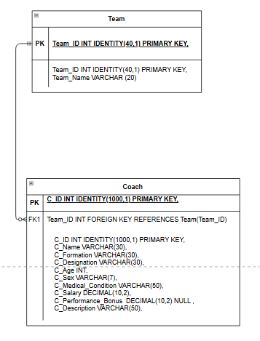
* One Ground and gym can have many staff
* One player can be sell one

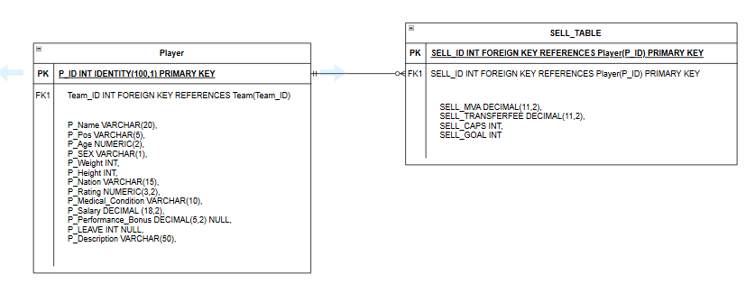

**4. SQL Queries**

1. **Create a database.**

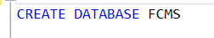

1. **Create the Table**

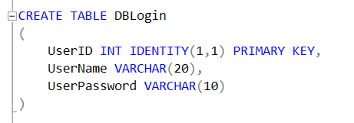

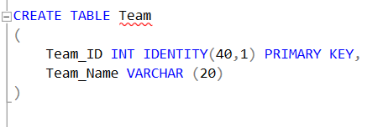

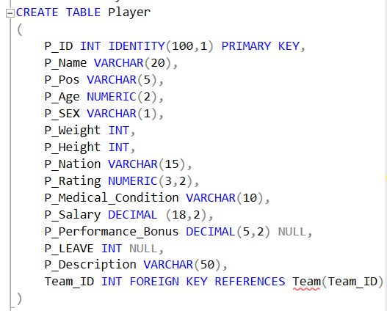

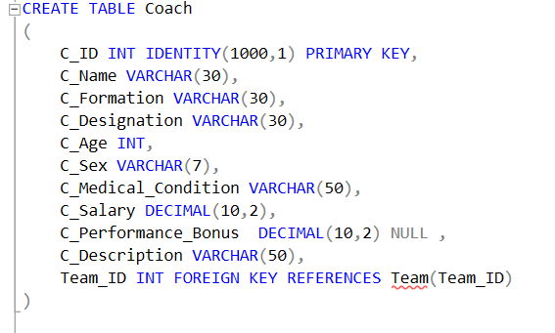

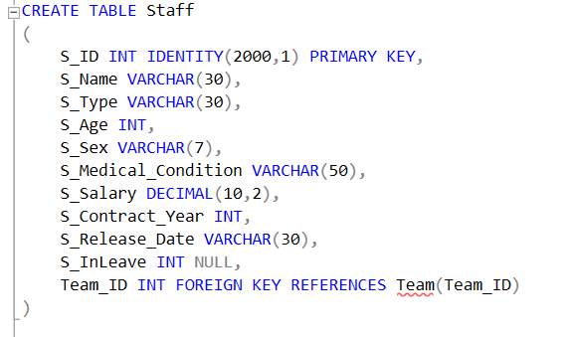

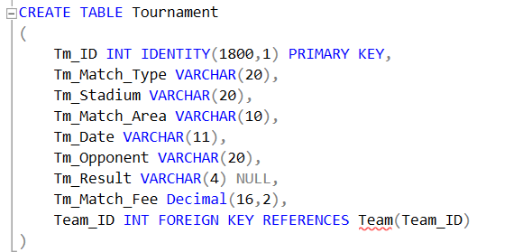

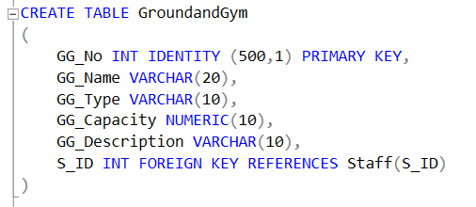

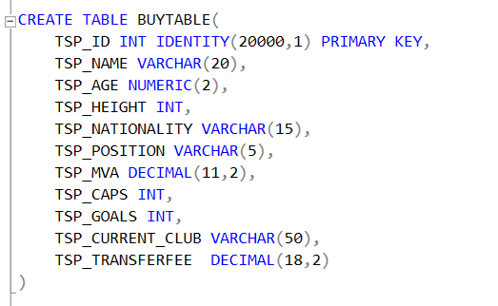

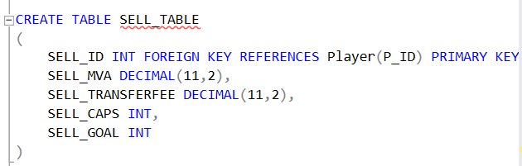

**IV. USER INTERFACE**

Create a user interface (UI) for football player management software, including designing an intuitive and user-friendly layout to meet the needs of coaches and analysts. Below is the specification for the design of our football player management software interface, which provides a comprehensive platform for overseeing players, coaching staff, transfers, facilities, and tournaments.

1. **Login**

The first step to accessing the Football Management Software is the login screen. Here, you'll need to enter your credentials to securely access the system.

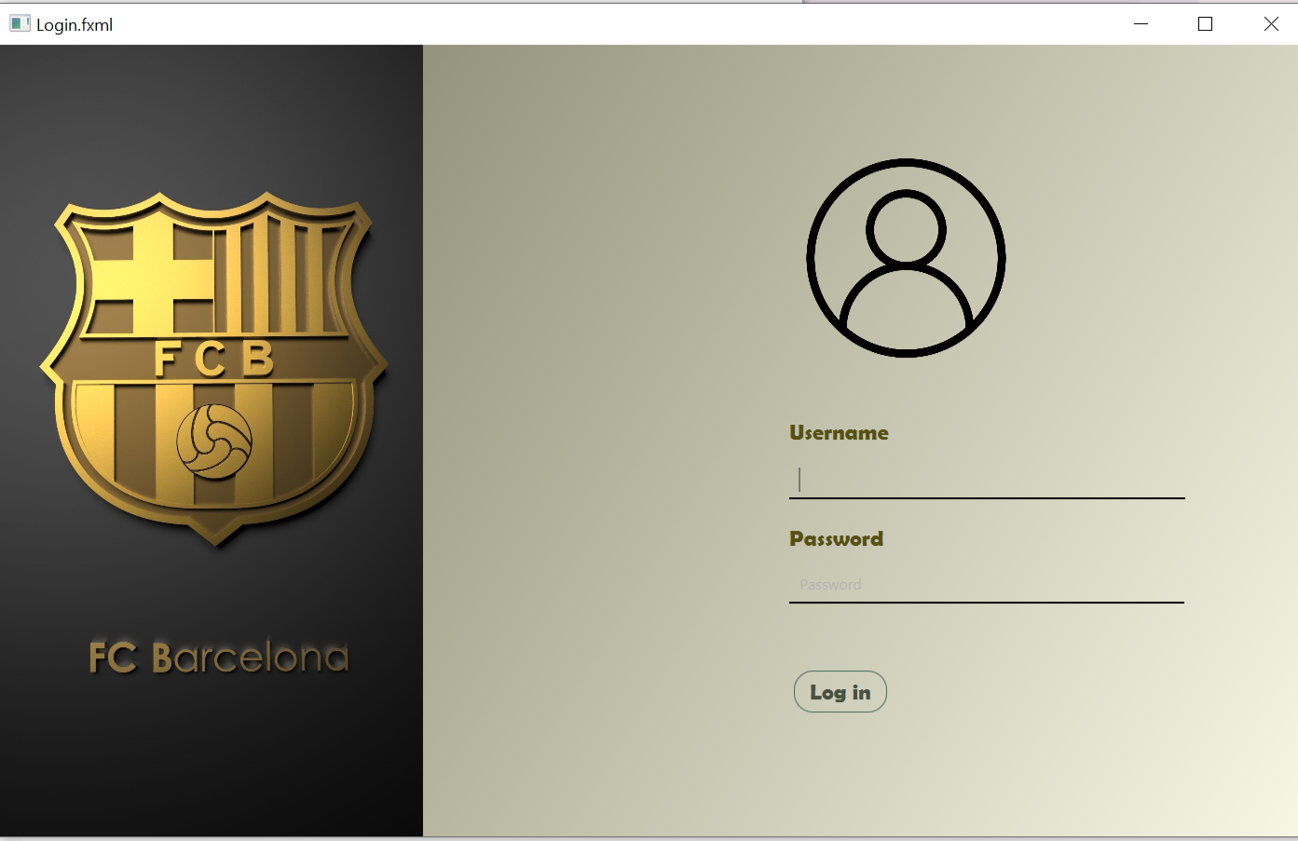

Login Page Features:

* **Username Field**: Enter your registered username.
* **Password Field**: Enter your secure password.
* **Login Button**: Submit your credentials to access the main interface.

1. **Main menu:**

Once logged in, you will be greeted with the Main Menu. This is your hub for navigating the various features of the Football Management Software.

**Main menu option:**

**2.1. Players**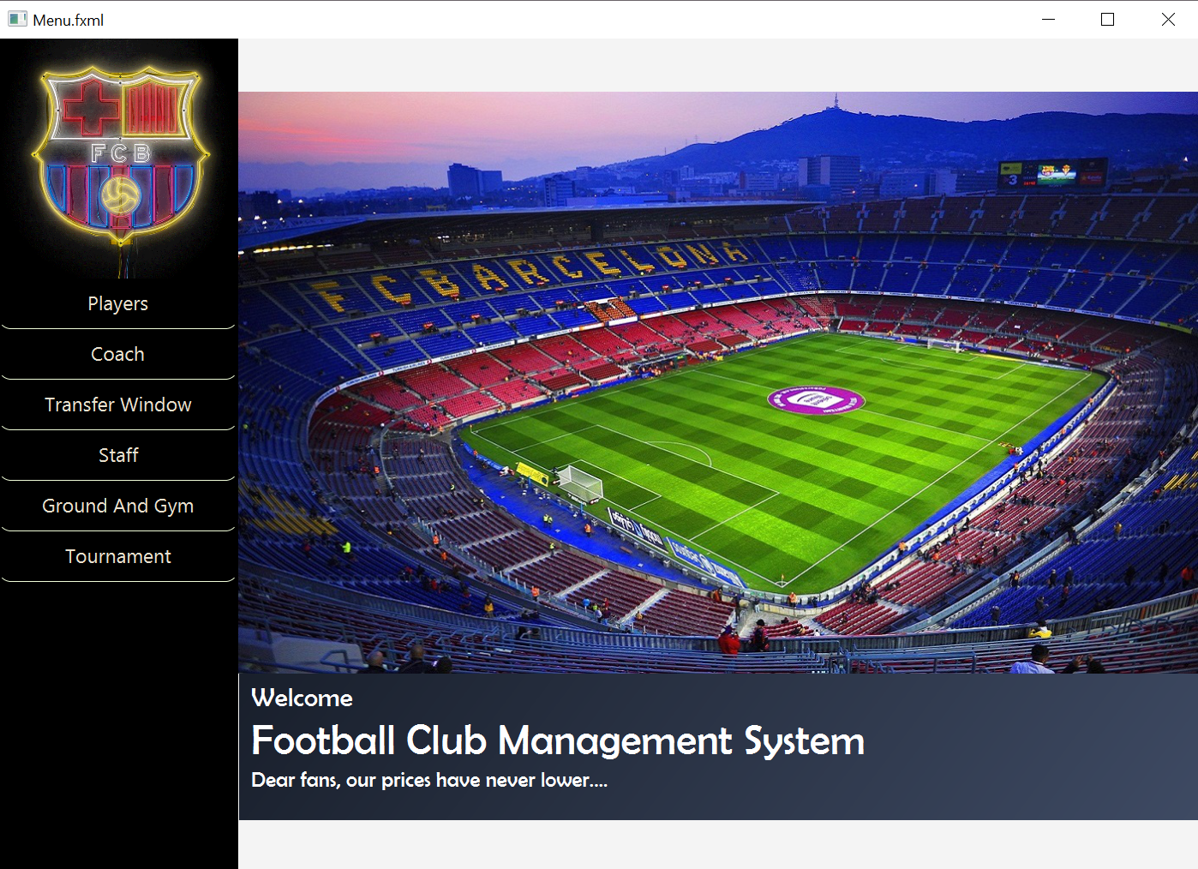

Manage all aspects related to your team's players.

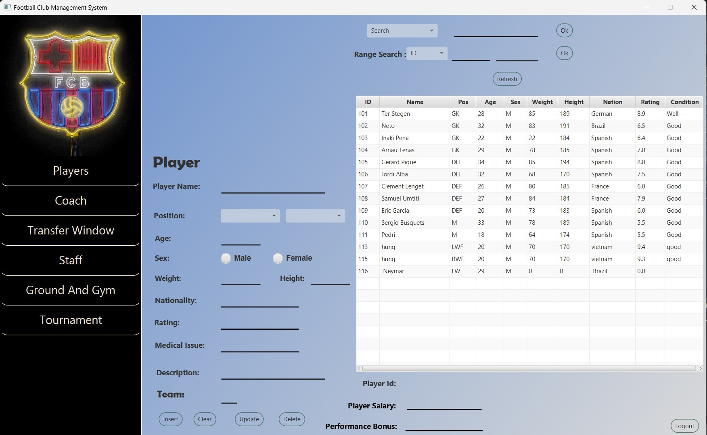

* **View Players:** See a list of all registered players.
* **Add/Edit Player**: Add new players or edit existing player details (Name, Position, Age, Sex, Weight, Height, Nationality, Rating, Media issue, Description, Team, ID, Salary, and Performance Bonus).

**2.2. Coach**

Manage all aspects related to your team's coach.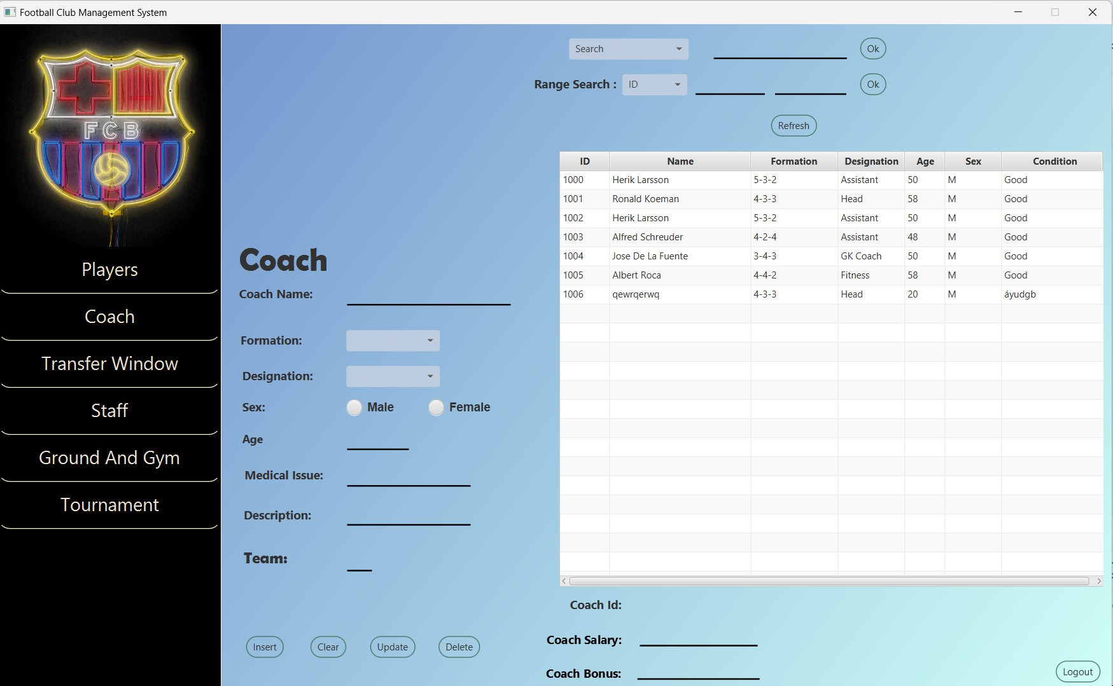

* **View Coaches:** List of all coaching staff.
* **Add/Edit Coach:** Add new coaches or update details of existing coaches. (Add: Name, Formation, Designation, Sex, Age, Medical issue, Description, Team, ID, Salary and Coach Bonus)

**2.3. Transfer Window**

Handle all player transfers and related activities.

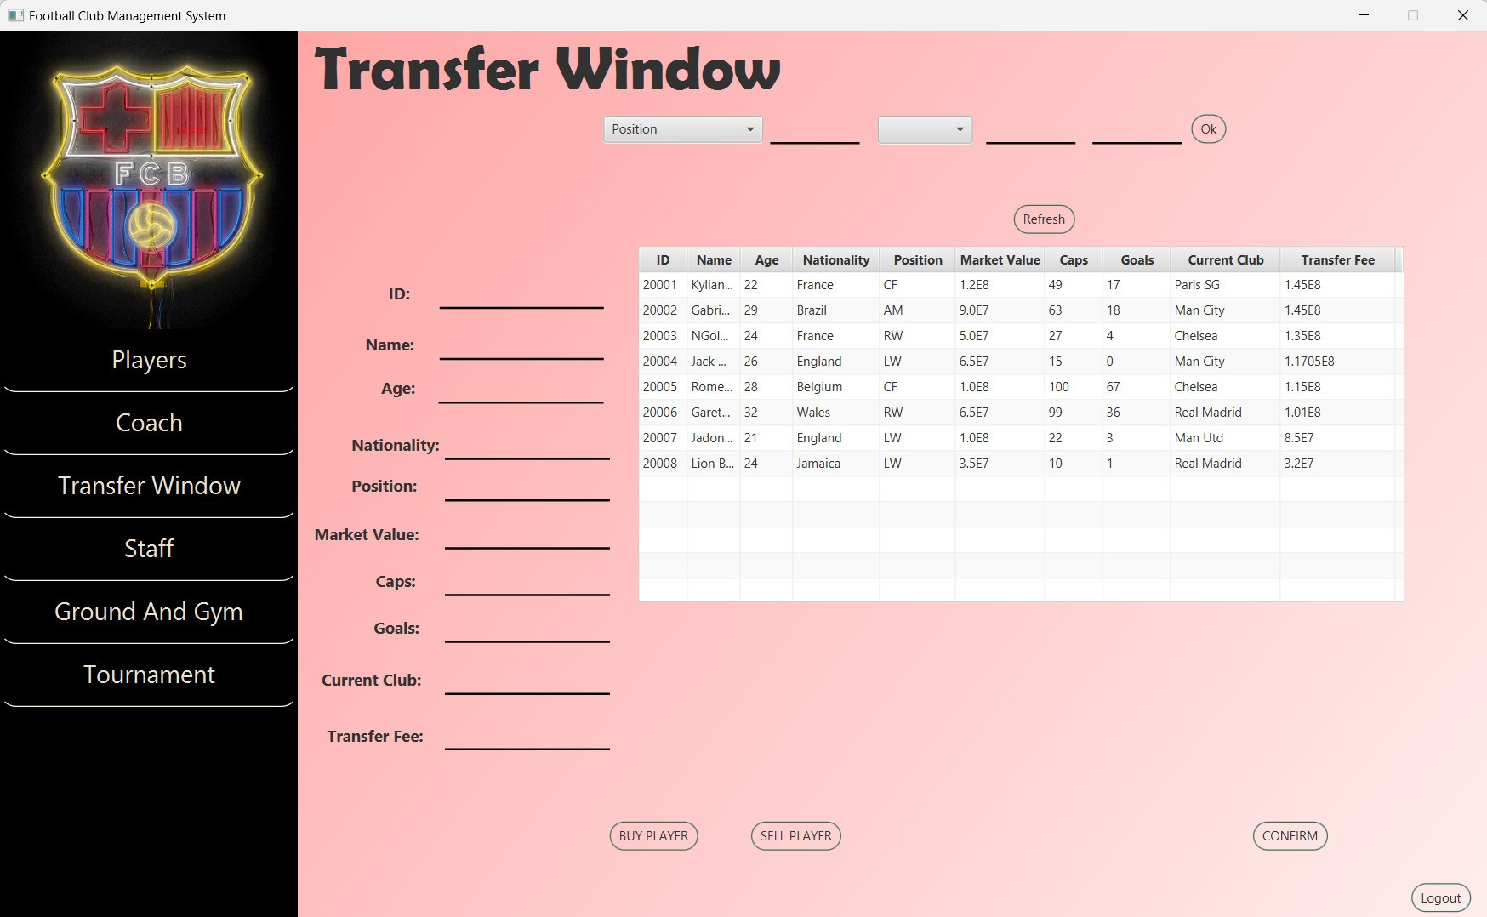

* **View Transfer List**: See all available and targeted players for transfer.
* **Initiate Transfer**: Start the process of buying or selling a player. (Add: ID, Name, Age, Nationality, Position, Market Value, Caps, Goals, Current Club and Transfer Fee)

**2.4. Staff**

Manage your club's administrative and support staff.

* **View Staff:** List of all non-coaching staff members.
* **Add/Edit Staff**: Add new staff members or update their details. (Add: Name, ID, Type, Sex, Age, Medical issue, Team and Salary)

**2.5. Ground and Gym**

Supervise the exercise schedule and training with the manager of the players.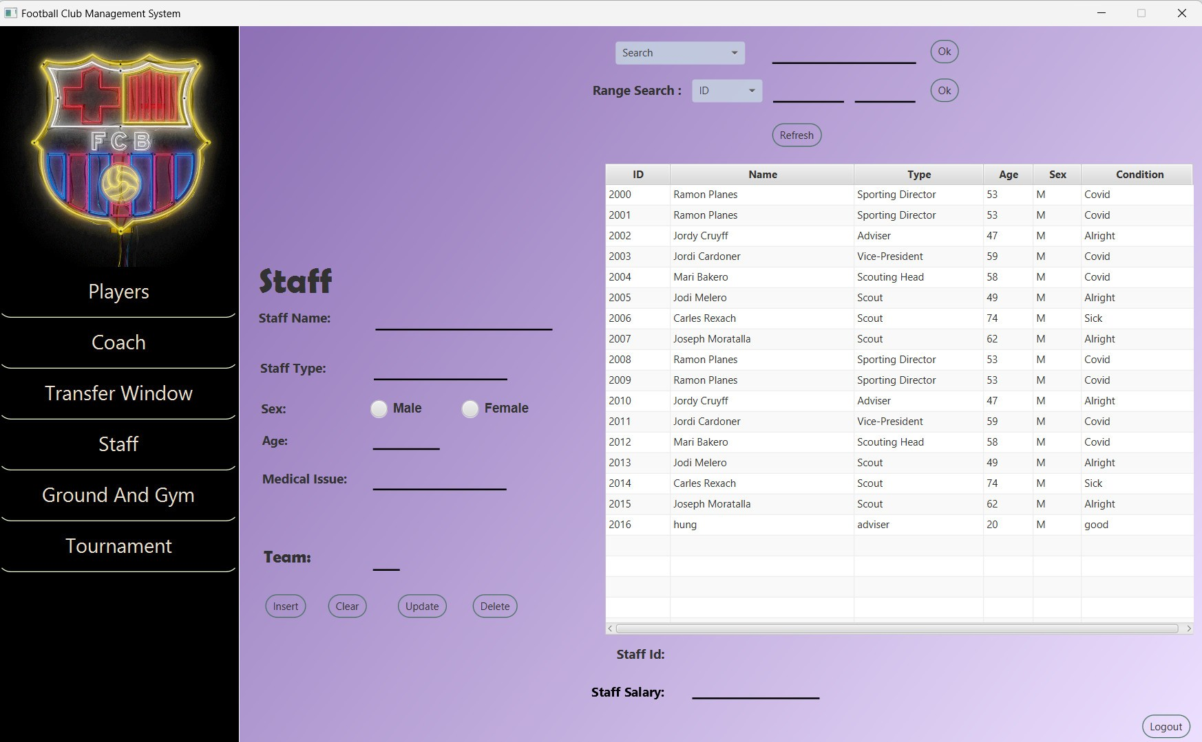

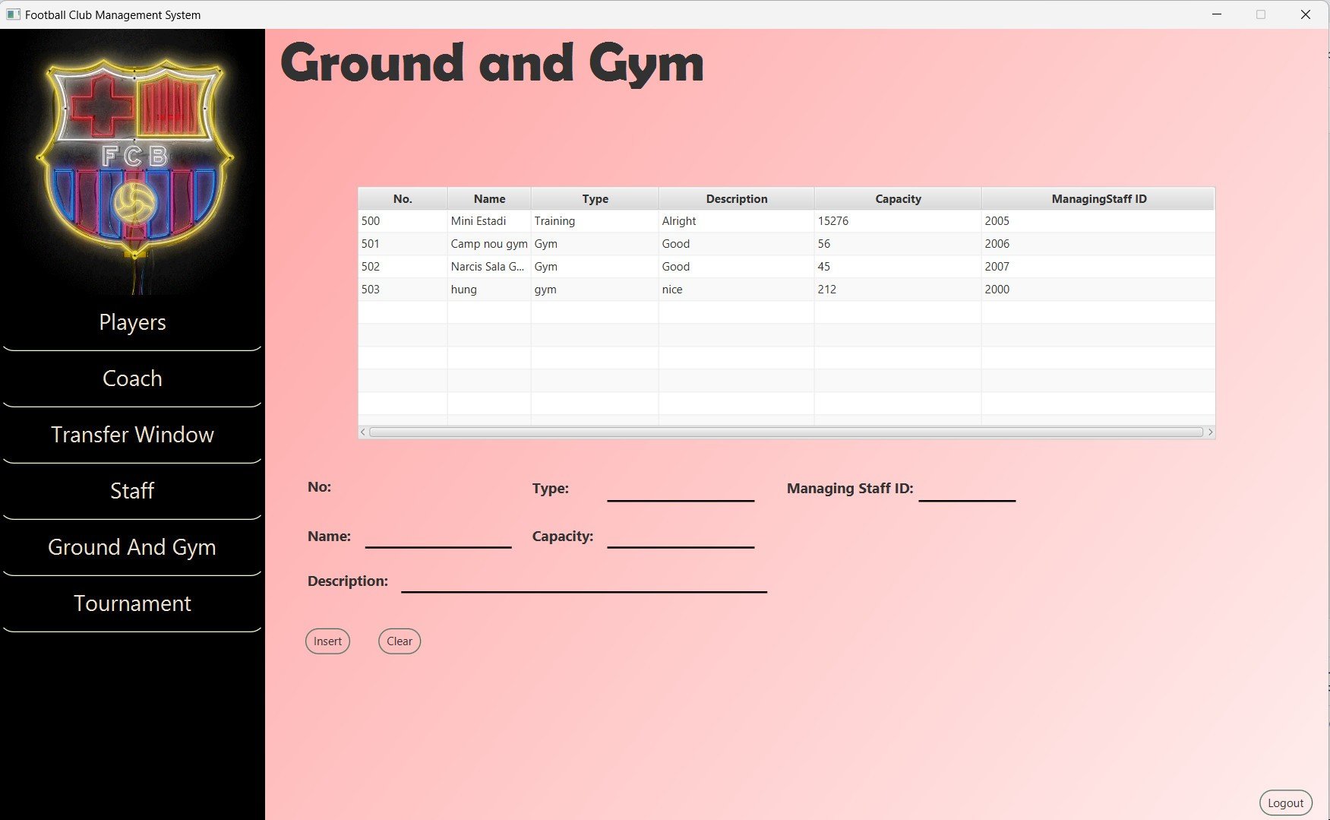

* **Overview**: List of all fitness and training status of the players.
* **Add/ Edit**: Add new training status of players. (Name, Type, Capacity, Description, Managing Staff ID)

**2.6. Tournament**

Manage participation in tournaments and competitions.

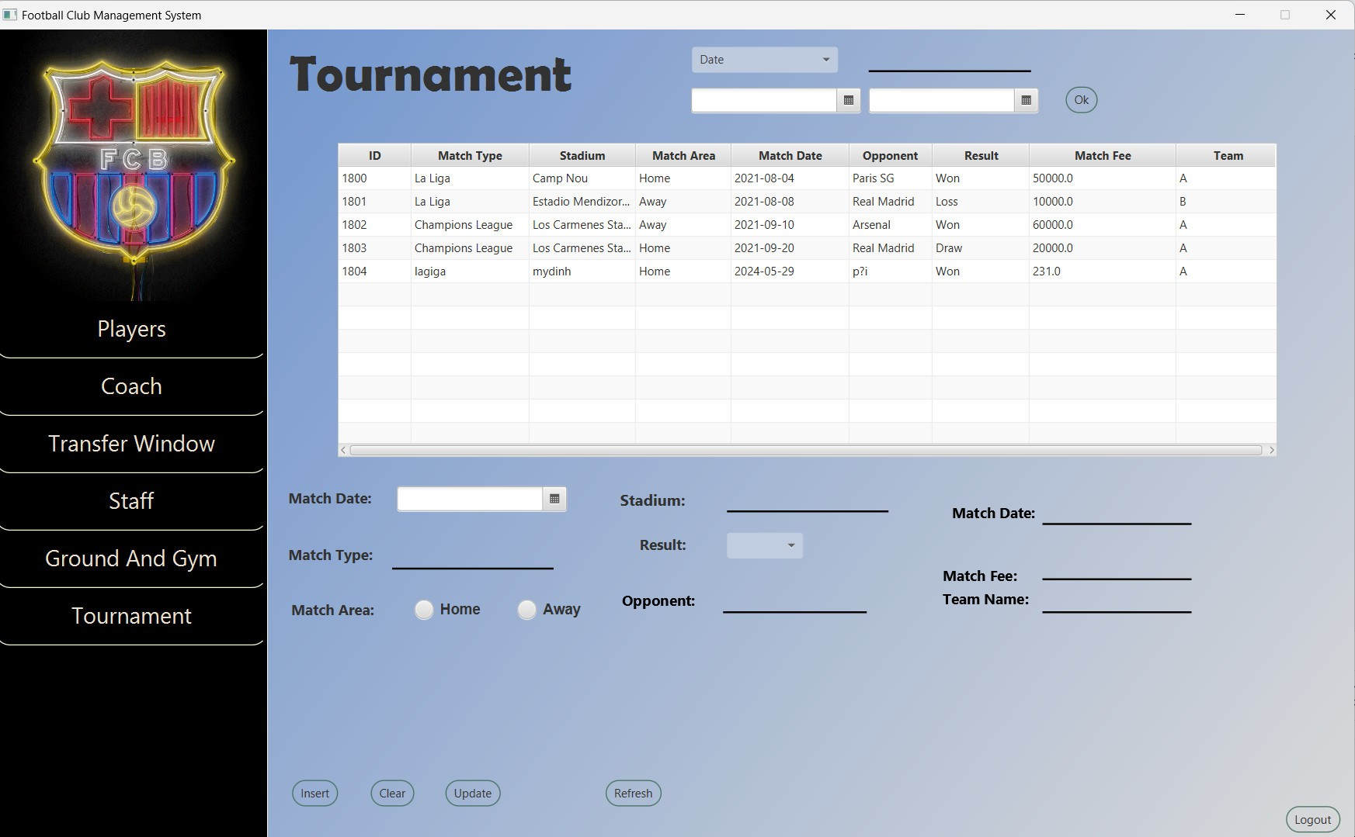

* **Upcoming Tournaments**: List and details of upcoming tournaments.
* **Schedule**: View match schedules and fixtures.
* **Results**: Track and review results of past matches and tournaments.

**3. Logout**

Securely log out of the Football Management Software when you are finished with your tasks.

By offering these features, our Football Management Software ensures that every aspect of running a club and managing players is comprehensively covered, allowing you to focus on achieving success both on and off the pitch.

**V. CODING & RELEASE**

1. **Login code**

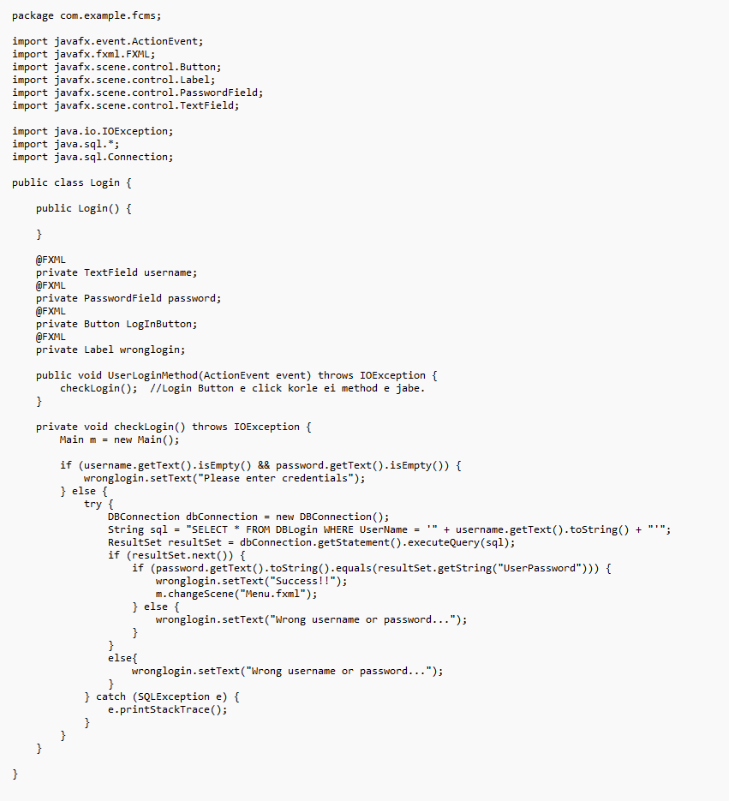

Defines a class named Login in a Java package. This class likely represents a login screen for a football club management system (FCMS).

The code defines variables for the username text field (username), password field (password), login button (LogInButton), and a label for displaying error messages (wrongLogin).

* It first checks if both the username and password fields are empty. If so, it displays an error message in the wrongLogin label.
* If credentials are provided, it creates a new instance of DBConnection (
* It constructs a SQL query to select all columns (*) from the DBLogin table where the UserName matches the entered username.
* It executes the query and retrieves the result set (resultSet).
* If a record is found (resultSet.next() returns true), it proceeds to check if the password entered by the user matches the password stored in the database (UserPassword column).
  + If the password matches, it displays a success message and calls the changeScene method from the Main class (likely to switch to the main menu screen).
  + If the password doesn't match, it displays an error message indicating incorrect username or password.
* If no record is found (else block after resultSet.next()), it displays an error message indicating incorrect username or password.

1. **Player code**

**2.1. Manage player information**

1. **Insert Player**

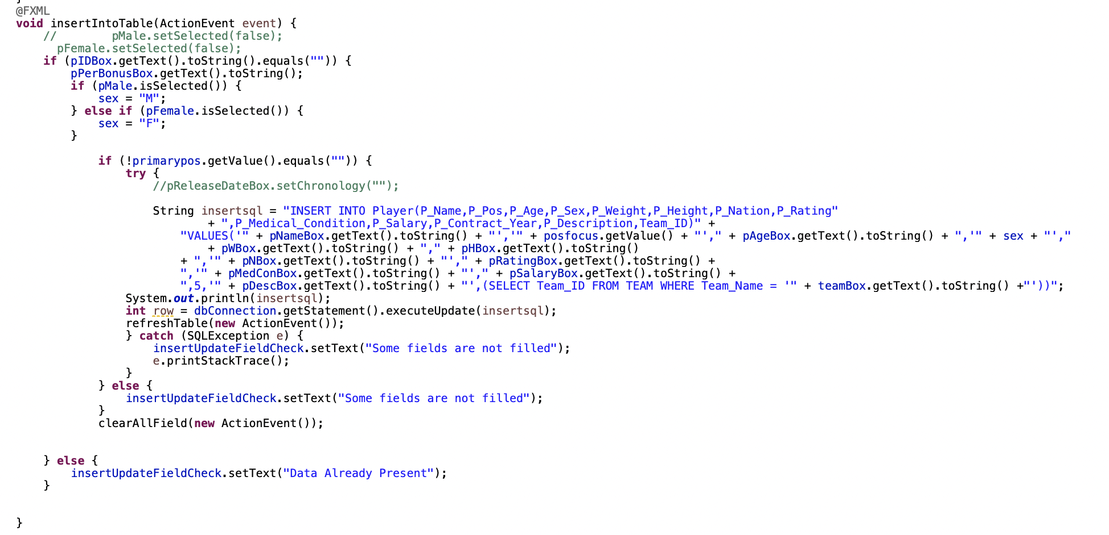

1. **Update Player**

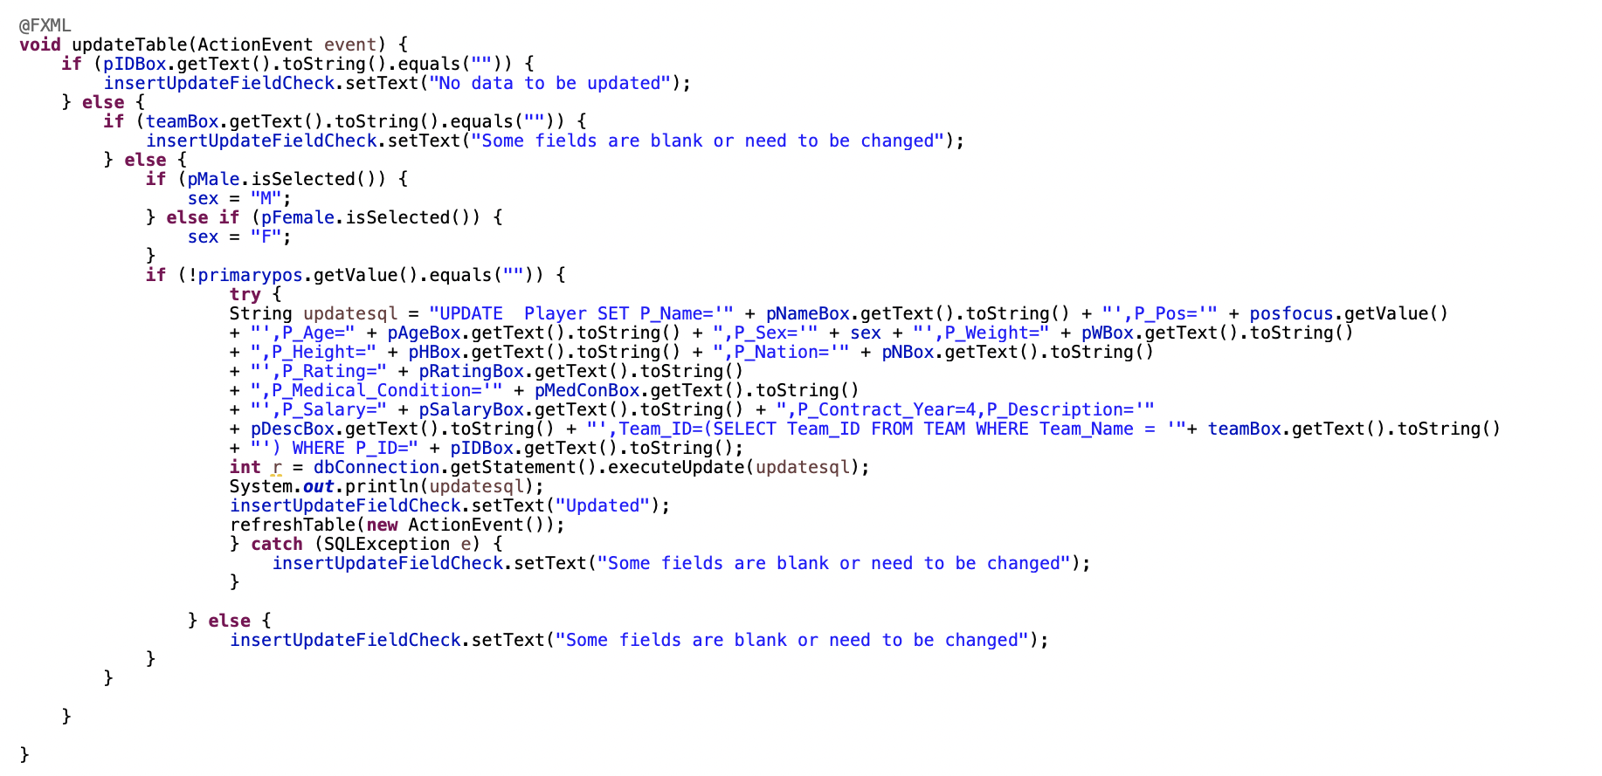

1. **Delete Player**

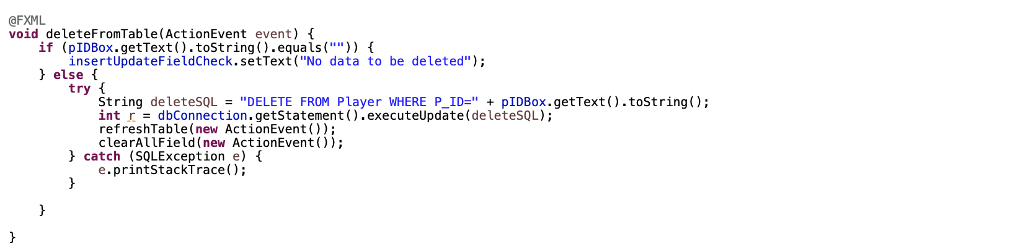

1. **TransferWindow**

**3.1. Initialization and Setup**

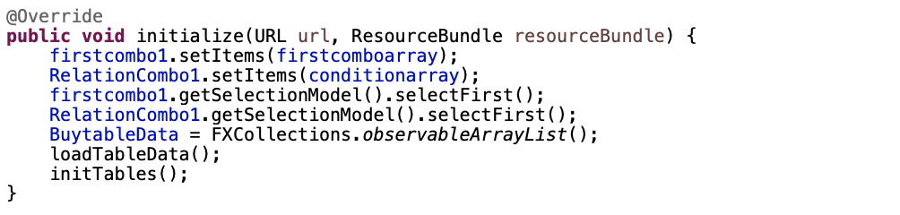

Sets up initial data and UI components when the screen is loaded

**3.2. Load and Initialize Table Data**

1. **Load Table**

Loads player transfer data into the table

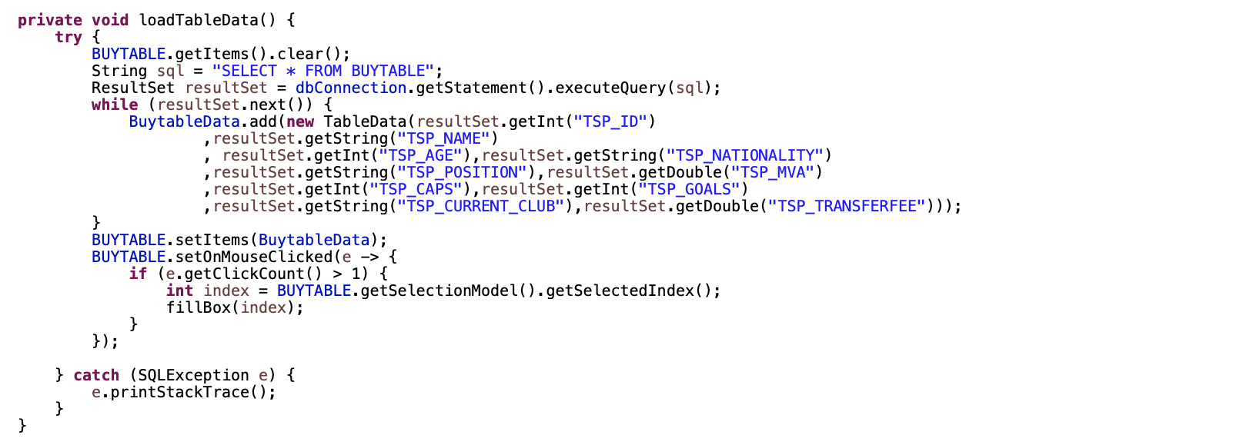

1. **Initialize**

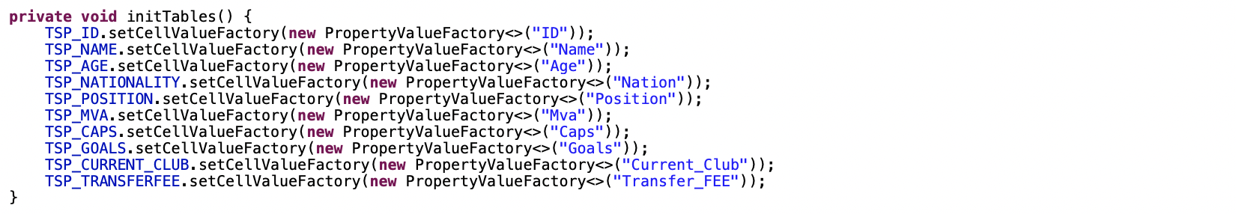

Initializes table columns with data properties

**3.3. Transfer Player**

1. **Buy player**

Transfers a player from the transfer table to the player table

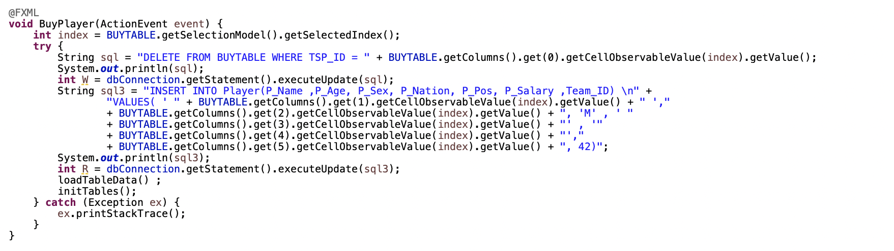

1. **Search player**

Searches for players based on criteria.

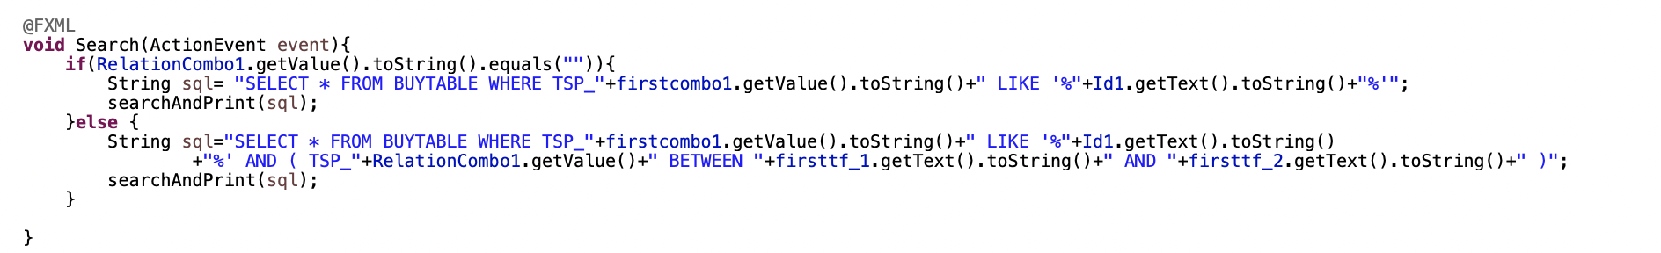

1. **Coach**
2. **Insert Coach Data**

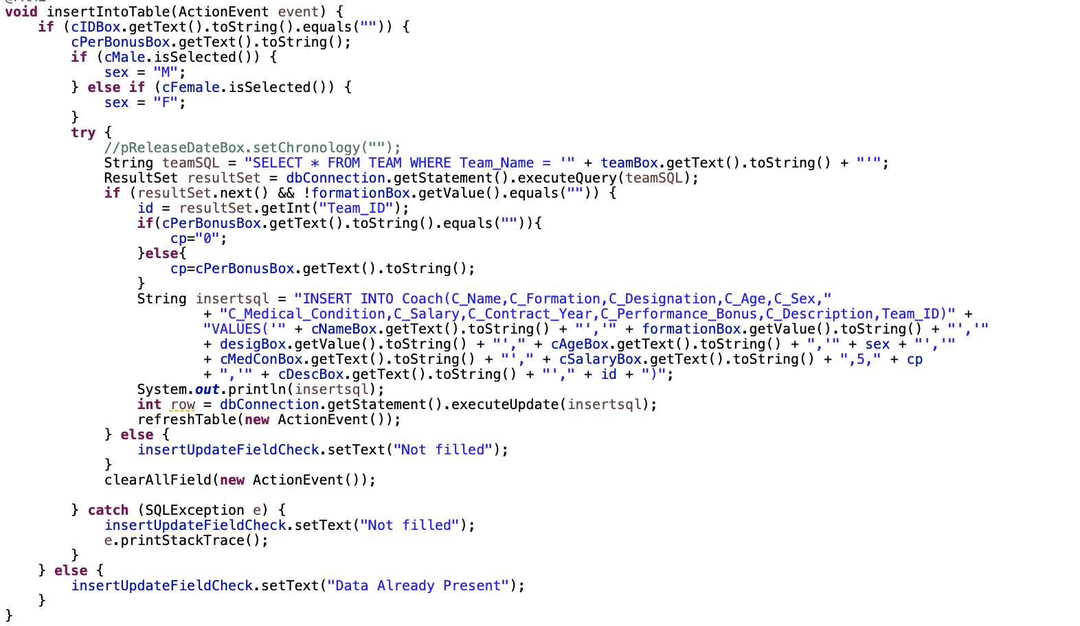

1. **Update Coach**

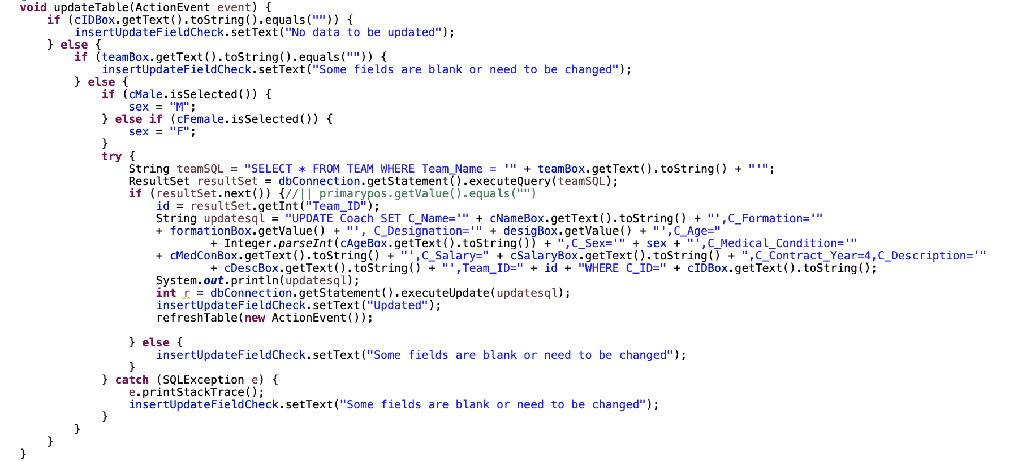

1. **Delete Coach**

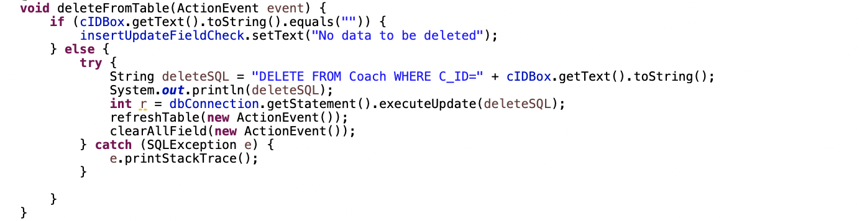

Deletes a coach record from the database

1. **Search**

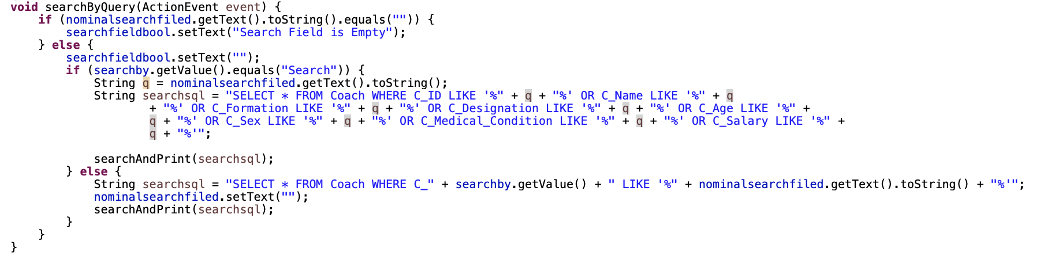

1. **Staff**
2. **Insert staff**

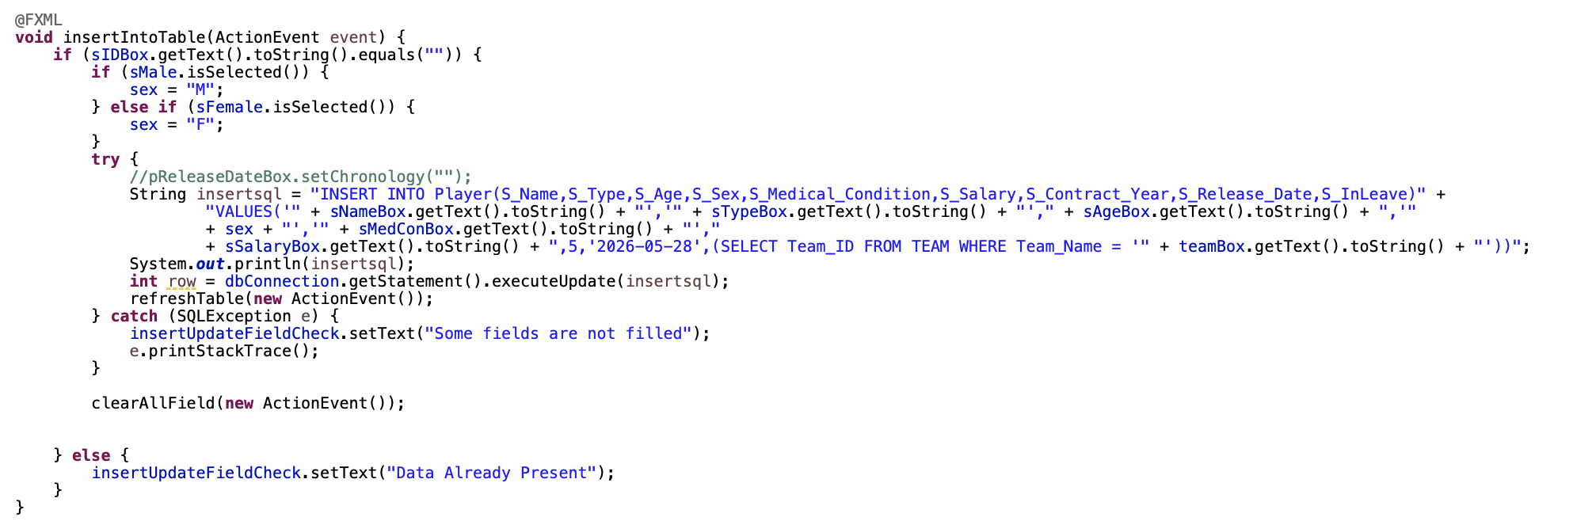

1. **Update Staff**

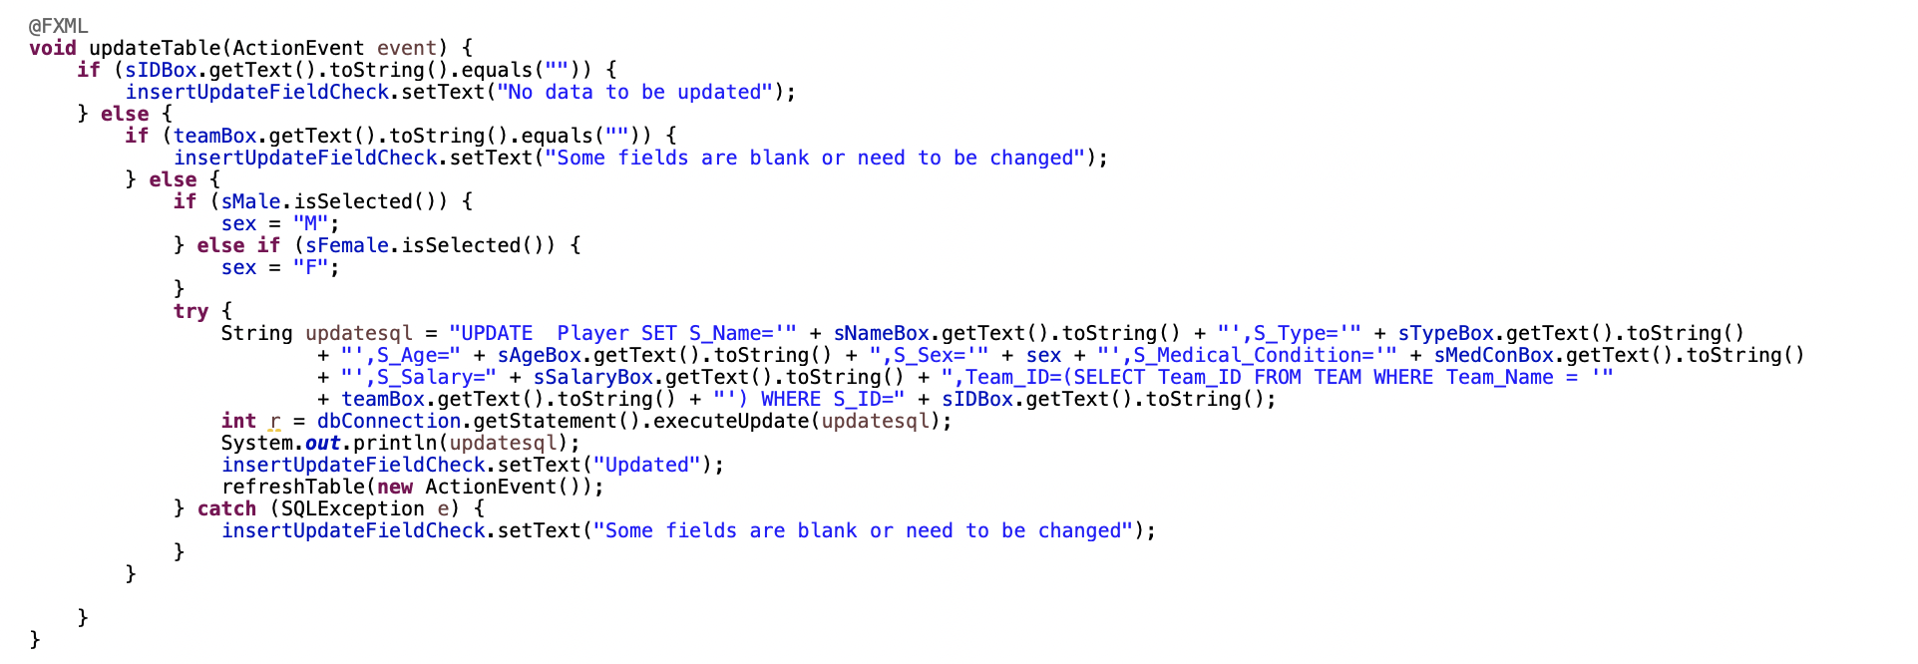

1. **Delete Staff**

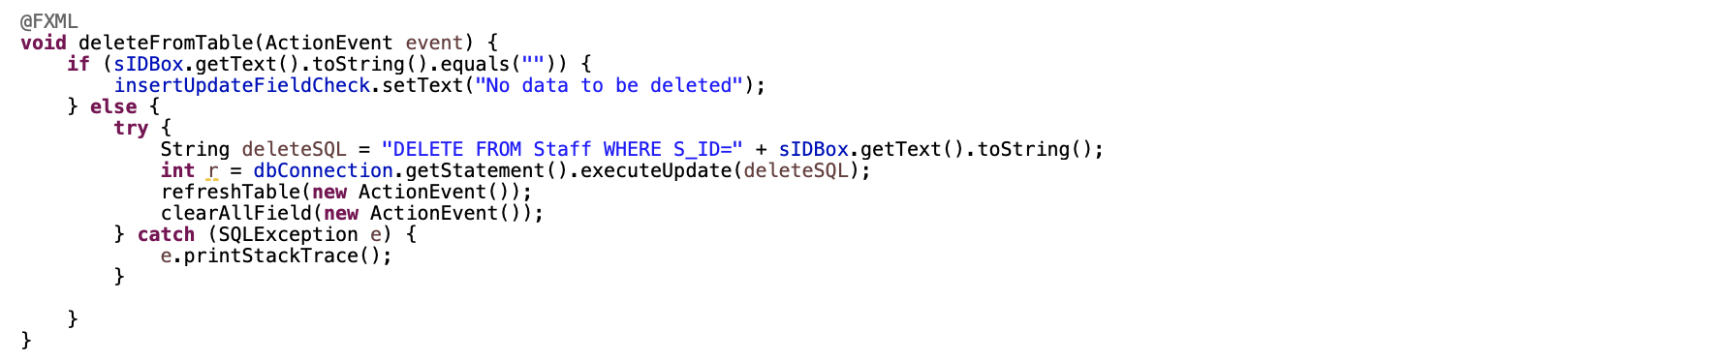

1. **Ground And Gym**
2. **Insert Ground and Gym Data**

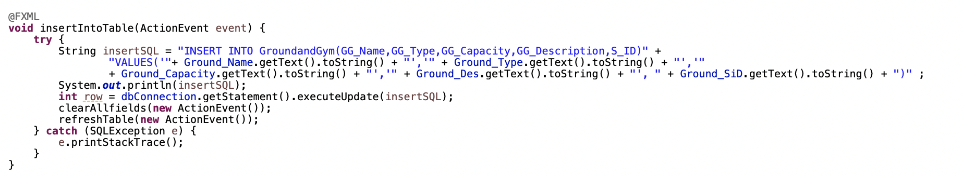

Inserts new ground and gym data into the database.

1. **Clear All Fields**

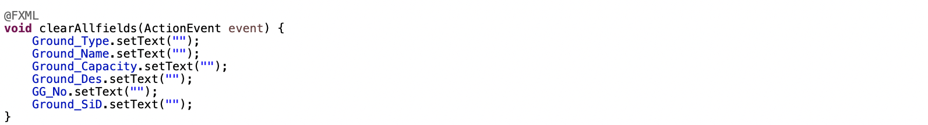

Clears all input fields.

1. **Refresh Table Data**

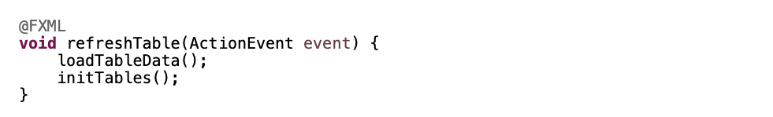

Refreshes the data in the table.

1. **Fill Input Fields**

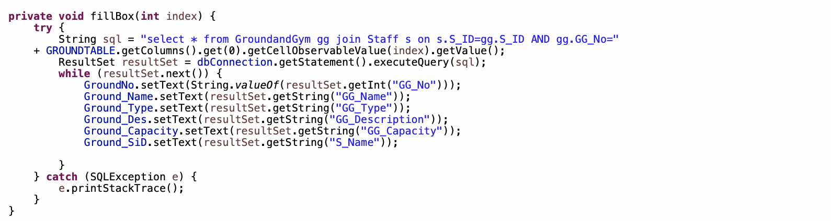

Populates the input fields with the details of the selected ground and gym from the table.

1. **Tournament**
2. **Insert Tournament Data**

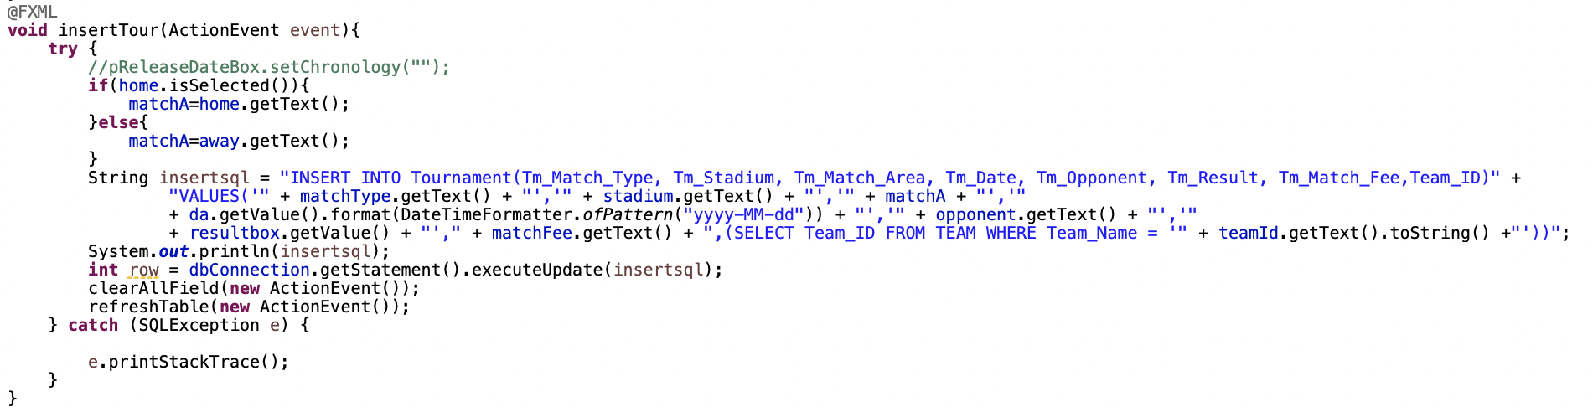

Inserts new tournament data into the database.

1. **Search by Criteria**

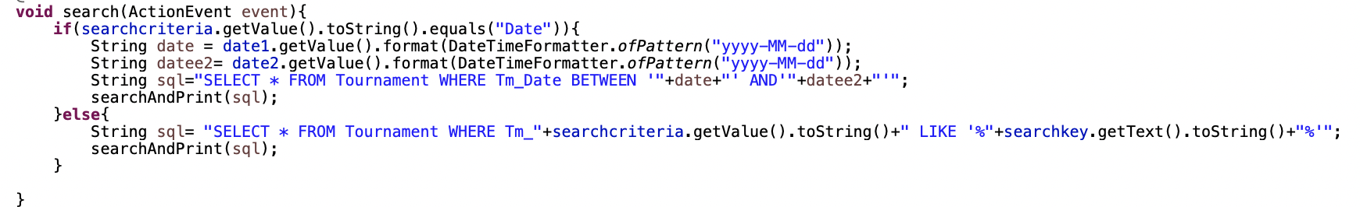

Searches for tournament records based on the selected criteria

1. **Fill Input Fields**

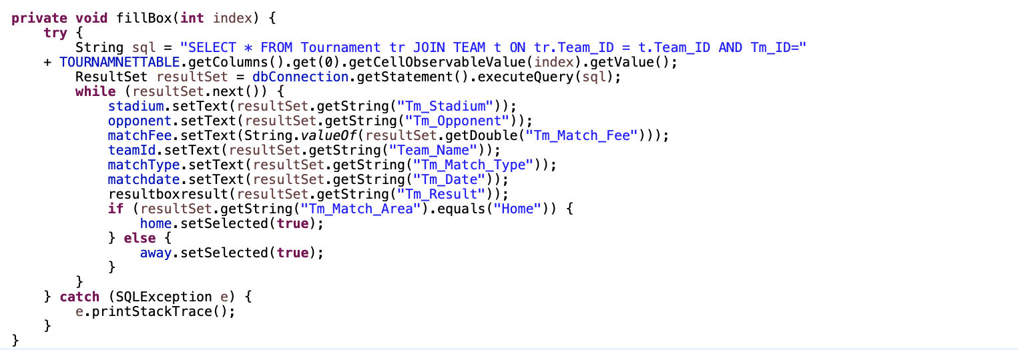

Populates the input fields with the details of the selected tournament from the table

**8. Log Out**

Logs out the user by changing the current scene to the login screen



**VI) CONCLUSION**

Overall, the Java soccer system is a powerful and versatile tool that can be used for various purposes. With its realistic simulation capabilities, flexibility, expandability, educational value, and entertainment value, this system is a valuable asset for anyone interested in soccer.

In the future, the System can be further improved by adding new features such as artificial intelligence to simulate player and coach behavior more realistically, or by integrating data from Realistic football to create a more realistic simulation experience. With its immense growth potential, this system promises to bring even more benefits to users in the future.

**VII) CONTRIBUTION**

| **NO** | **Họ và tên** | **MSSV** | **CONTRIBUTION** |
| --- | --- | --- | --- |
| **1** | Thân Quang Huy | 22070248 | 20% |
| **2** | Nhữ Quang Minh | 22070406 | 20% |
| **3** | Nguyễn Thế Hùng | 22070294 | 20% |
| **4** | Nguyễn Thu Phương | 21070778 | 20% |
| **5** | Nguyễn Thị Ngọc Diệp | 20070685 | 20% |
| **TOTAL** | | | 100% |

_*THE END_*

# 